  
  Healthy Living Nutrition Classes
  Join us for 8 weekly sessions provided by:
  Food Bank of the Rio Grande Valley, beginning on October 10, 2019
  At 11:00 a.m.
  Veterans Memorial Parent Center
  For further information please contact:
  Anna Garcia (956) 323-3000
  cccccC
  Free Classes
  Gra
  Cooking Demonstrations
  Learn to prepare
  Healthy Snacks!
  h
  Weekly sessions
  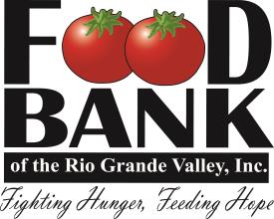
  Veterans Memorial
  High School
  700 E. 2 Mile Rd.
  Mission, Tx. 78572
  Join us!

